Exercise 1 : Implementation of Singleton Pattern

Code :

Logic and Implementation Code For Singleton Pattern :
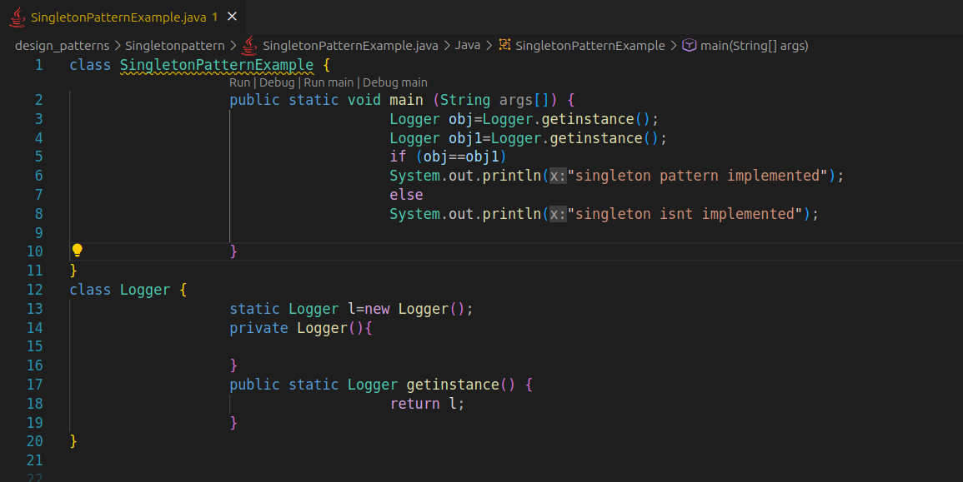

Output :

